BLG 506E COMPUTER VISION ASSIGNMENT 3

Two Layer Neural Networks
We will use two_layer_net_ipynb notebook and neural_net.py files for this assignment.
We initialize toy data and a toy model that we will use to develop your implementation.
def init_toy_model():
np.random.seed(0)
return TwoLayerNet(input_size, hidden_size, num_classes, std=1e-1)
When we call to “TwoLayerNet(object)”, firstly enter into “__init__() “ function. So Initialize the model here. Weights are initialized to small random values and biases are initialized to zero.

def __init__(self, input_size, hidden_size, output_size, std=1e-4):
self.params = {}
self.params['W1'] = std * np.random.randn(input_size, hidden_size)
self.params['b1'] = np.zeros(hidden_size)
self.params['W2'] = std * np.random.randn(hidden_size, output_size)
self.params['b2'] = np.zeros(output_size)
TwoLayerNet has an input dimension of N and D features, a hidden layer dimension of H, and performs classification over C classes.
we initialized __init__(self, input_size, hidden_size, output_size, std=1e-4) function.
Here, Inputs:
- input_size: The dimension D of the input data.
- hidden_size: The number of neurons H in the hidden layer.
- output_size: The number of classes C.
and shape of parameters that we initialized:
- W1: First layer weights; has shape (D, H)
- b1: First layer biases; has shape (H,)
- W2: Second layer weights; has shape (H, C)
- b2: Second layer biases; has shape (C,)
Then, we open TwoLayerNet.loss function in cs231n/classifiers/neural_net.py and compute scores using weights and biases, so we perform forward pass.

def loss(self, X, y=None, reg=0.0):
# Unpack variables from the params dictionary
W1, b1 = self.params['W1'], self.params['b1']
W2, b2 = self.params['W2'], self.params['b2']
N, D = X.shape

# Compute the forward pass
scores = None
# *****START OF YOUR CODE (DO NOT DELETE/MODIFY THIS LINE)*****
fc1 = X.dot(W1) + b1 # fully connected-1
af1 = np.maximum(0, fc1) # use ReLU as activation function
scores = af1.dot(W2) + b2 # fully connected-2
# *****END OF YOUR CODE (DO NOT DELETE/MODIFY THIS LINE)*****

# If the targets are not given then jump out, we're done
if y is None:
return scores

# Compute the loss
loss = None
# *****START OF YOUR CODE (DO NOT DELETE/MODIFY THIS LINE)*****

#we calculate scores above
#calculate softmax loss
#N = X.shape[0]
#P = e^s/Sum(e^s), s = f(xi,W), keep dimenson.
P = np.exp(scores)/np.sum(np.exp(scores), axis=1, keepdims=True)

L = -np.sum(np.log(P[np.arange(N), y]))#L =sum(-log(P))
# Average loss
loss= L/N #X.shape[0]

# add Regularization to loss
loss += reg * (np.sum(W2 * W2) + np.sum( W1 * W1 ))
# L2 regularization, R(W1) + R(W2) = Sum(W1*W1) + Sum(W2*W2)

# *****END OF YOUR CODE (DO NOT DELETE/MODIFY THIS LINE)*****

This loss function takes the data and weights and computes the class scores, the loss, and the gradients on the parameters.
Firstly, we unpack variables from “params dictionary”. Then we perform forward pass.
Scores = f = W2.max(0,W1x + b1) + b2

Here, we use ReLu activation function.

# *****START OF YOUR CODE (DO NOT DELETE/MODIFY THIS LINE)*****

fc1 = X.dot(W1) + b1 # fully connected-1

af1 = np.maximum(0, fc1) # use ReLU as activation function

scores = af1.dot(W2) + b2 # fully connected-2

# *****END OF YOUR CODE (DO NOT DELETE/MODIFY THIS LINE)*****
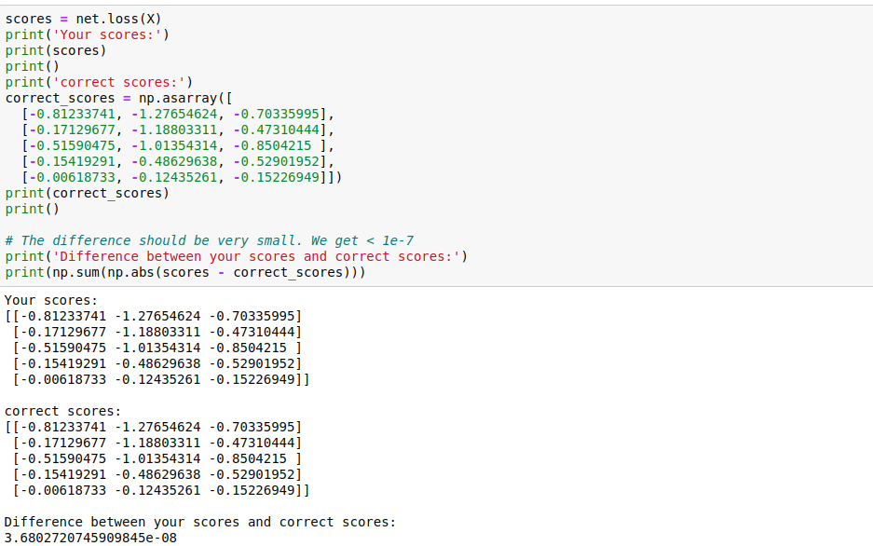

After the forward pass we need to compute the loss. Here, we use Softmax Loss.
Softmax loss is:
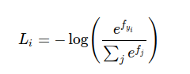

P = e^s/Sum(e^s), s = f(xi,W)
L =sum(-log(P))
Then we calculate average loss and add regularization both W1 and W2.
R(W1) + R(W2) = Sum(W1*W1) + Sum(W2*W2)

# *****START OF YOUR CODE (DO NOT DELETE/MODIFY THIS LINE)*****
#N = X.shape[0]
P = np.exp(scores)/np.sum(np.exp(scores), axis=1, keepdims=True)
#P = e^s/Sum(e^s), s = f(xi,W), keep dimenson.
L = -np.sum(np.log(P[np.arange(N), y]))#L =sum(-log(P))
# Average loss
loss= L/N #X.shape[0]

# L2 regularization, R(W1) + R(W2) = Sum(W1*W1) + Sum(W2*W2)
loss += reg * (np.sum(W2 * W2) + np.sum( W1 * W1 ))

# *****END OF YOUR CODE (DO NOT DELETE/MODIFY THIS LINE)*****

We use keepdims=True in P = np.exp(scores)/np.sum(np.exp(scores), axis=1, keepdims=True) formule. Because, operands could not be broadcast together with shapes.
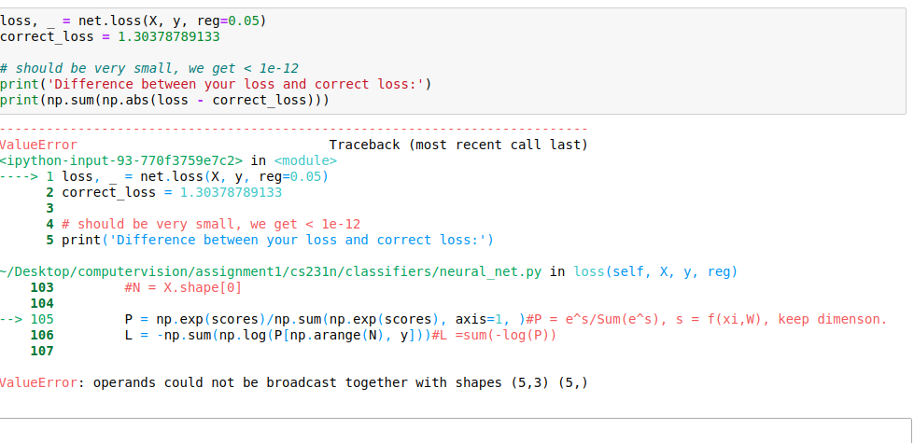

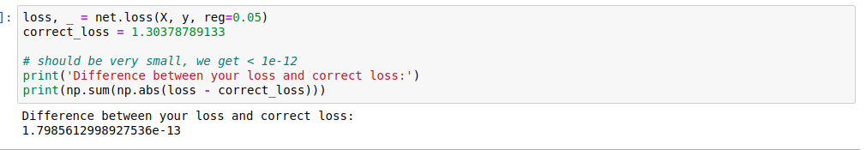
Then we perfoms backward pass. We implement the rest of the function. This will compute the gradient of the loss with respect to the variables W1, b1, W2, b2.
# Backward pass: compute gradients
grads = {}
# *****START OF YOUR CODE (DO NOT DELETE/MODIFY THIS LINE)*****
#gradient of softmax = Xi*(1 - pi) if i = j, so Xi - Xi*pi and subtract Xi from i!=j case
P[np.arange(N) ,y] -= 1
P /= N #Avarage

#Because of we calculate Backward pass, find firstly gradient of W2 and then gradient of W1
#To calculate gradient of Weight , we use this formule = dW = X.T.dot(p) from softmax.py

#W2 gradient
grads['W2'] = af1.T.dot(P)

#b2 gradient
grads['b2'] = P.sum(axis=0)

# W1 gradient
dW1 = P.dot(W2.T)

#because of we use ReLU above as activation function, we also need to get gradient of this.

dfc1 = dW1 * (fc1>0)
grads['W1'] = X.T.dot(dfc1)

# b1 gradient
grads['b1'] = dfc1.sum(axis=0)

# regularization gradient
grads['W1'] += reg * 2 * W1
grads['W2'] += reg * 2 * W2

# *****END OF YOUR CODE (DO NOT DELETE/MODIFY THIS LINE)*****

Here firstly, gradient of softmax is Xi*(1 - pi) if i = j, so Xi - Xi*pi and subtract Xi from i!=j case. Then we calculate average P.

P[np.arange(N) ,y] -= 1
P /= N
Then, because of we calculate Backward pass, find firstly gradient of W2 and then gradient of W1. To calculate gradient of Weight , we use this formule = dW = X.T.dot(p) from softmax.py
W2 gradient:
grads['W2'] = af1.T.dot(P)
b2 gradient:
grads['b2'] = P.sum(axis=0)
W1 gradient
dW1 = P.dot(W2.T)
And then, because of we used ReLU above as activation function, we also need to get gradient of this.
dfc1 = dW1 * (fc1>0)
grads['W1'] = X.T.dot(dfc1)
and finally,
b1 gradient:
grads['b1'] = dfc1.sum(axis=0)

Then we calculate regularization of W1 and W2 gradient
grads['W1'] += reg * 2 * W1
grads['W2'] += reg * 2 * W2

Train the network
To train the network we will use stochastic gradient descent (SGD).
def train(self, X, y, X_val, y_val,
learning_rate=1e-3, learning_rate_decay=0.95,
reg=5e-6, num_iters=100,
batch_size=200, verbose=False):

num_train = X.shape[0]
iterations_per_epoch = max(num_train / batch_size, 1)

# Use SGD to optimize the parameters in self.model
loss_history = []
train_acc_history = []
val_acc_history = []

for it in range(num_iters):
X_batch = None
y_batch = None

# *****START OF YOUR CODE (DO NOT DELETE/MODIFY THIS LINE)*****

batch_indices = np.random.choice(num_train, batch_size)#divide num train into batch size.
X_batch = X[batch_indices]
y_batch = y[batch_indices]

# *****END OF YOUR CODE (DO NOT DELETE/MODIFY THIS LINE)*****

# Compute loss and gradients using the current minibatch
loss, grads = self.loss(X_batch, y=y_batch, reg=reg)
loss_history.append(loss)

# *****START OF YOUR CODE (DO NOT DELETE/MODIFY THIS LINE)*****

#update the parameters
self.params['W1'] -= learning_rate * grads['W1']
self.params['b1'] -= learning_rate * grads['b1']
self.params['W2'] -= learning_rate * grads['W2']
self.params['b2'] -= learning_rate * grads['b2']

# *****END OF YOUR CODE (DO NOT DELETE/MODIFY THIS LINE)*****

if verbose and it % 100 == 0:
print('iteration %d / %d: loss %f' % (it, num_iters, loss))

# Every epoch, check train and val accuracy and decay learning rate.
if it % iterations_per_epoch == 0:
# Check accuracy
train_acc = (self.predict(X_batch) == y_batch).mean()
val_acc = (self.predict(X_val) == y_val).mean()
train_acc_history.append(train_acc)
val_acc_history.append(val_acc)

# Decay learning rate
learning_rate *= learning_rate_decay

return {
'loss_history': loss_history,
'train_acc_history': train_acc_history,
'val_acc_history': val_acc_history,
}
İn this function, firstly, we create a random minibatch of training data and labels. We divide num train into batch size.
# *****START OF YOUR CODE (DO NOT DELETE/MODIFY THIS LINE)*****

batch_indices = np.random.choice(num_train, batch_size)
X_batch = X[batch_indices]
y_batch = y[batch_indices]

# *****END OF YOUR CODE (DO NOT DELETE/MODIFY THIS LINE)*****

Then, we use the gradients in the grads dictionary to update the parameters of the network (stored in the dictionary self.params) using stochastic gradient descent.
# *****START OF YOUR CODE (DO NOT DELETE/MODIFY THIS LINE)*****
#update the parameters
self.params['W1'] -= learning_rate * grads['W1']
self.params['b1'] -= learning_rate * grads['b1']
self.params['W2'] -= learning_rate * grads['W2']
self.params['b2'] -= learning_rate * grads['b2']

# *****END OF YOUR CODE (DO NOT DELETE/MODIFY THIS LINE)*****
Then we implement net.predict function. We use argmax function in scores to predict.
def predict(self, X):
# *****START OF YOUR CODE (DO NOT DELETE/MODIFY THIS LINE)*****

scores = self.loss(X) #get scores
y_pred = np.argmax(scores, axis=1) #predict

# *****END OF YOUR CODE (DO NOT DELETE/MODIFY THIS LINE)*****
return y_pred
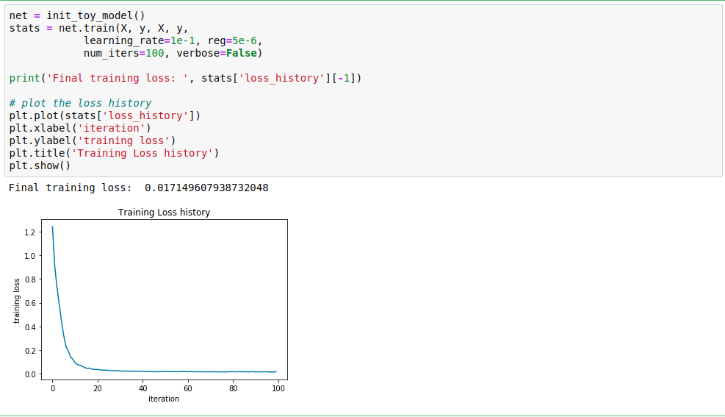

Load the data
Now we load up our CIFAR-10 data so we can use it to train a classifier on a real dataset. We split the data into 49000 train, 1000 validation and 1000 test sets.
Train data shape: (49000, 3072)
Train labels shape: (49000,)
Validation data shape: (1000, 3072)
Validation labels shape: (1000,)
Test data shape: (1000, 3072)
Test labels shape: (1000,)

Train a network

To train our network, we use Stochastic Gradient Descent (SGD).In addition, we adjust the learning rate with an exponential learning rate schedule as optimization proceeds; after each epoch, we reduce the learning rate by multiplying it by a decay rate.

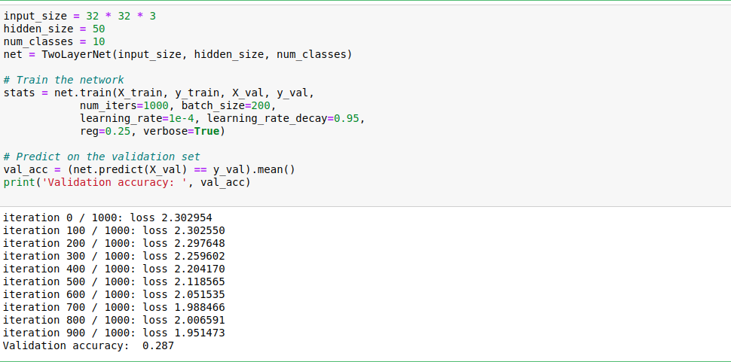

Debug the training
Now, we find that validation accuracy is 0.287 with default parameters. But this isn’t very good. So we need optimization.
One strategy for getting insight into what's wrong is to plot the loss function and the accuracies on the training and validation sets during optimization.

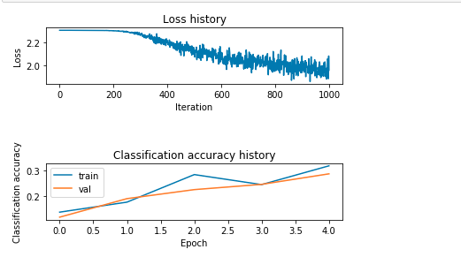

Another strategy is to visualize the weights that were learned in the first layer of the network. In most neural networks trained on visual data, the first layer weights typically show some visible structure when visualized.
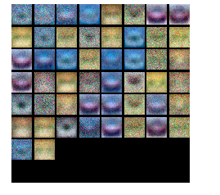

Tune your hyperparameters
Inline Question:
Explain your hyperparameter tuning process below
Answer: We tune 3 parameters here: regularization, learning rate and hidden layer. Here we want to find the best model in this network by changing these 3 parameters.

I will get 50, 100, 150, 200 values as hidden size.
I will use values between 10 ^ -4 and 10 ^ 0 as the regularization strength.
I will use values between 10 ^ -3 and 10 ^ -4 as the Learning Rate.
These values are my initial values for now. If validation accuracy does not come out as expected, I will try to optimize my network by changing these values.

Here, for each hidden size value, I will train a model by choosing randomly in the range in which I set the learning rate and regularization strength values in each iteration.

If I cannot find a validation accuracy of around 52%, I will retrain by changing these values.

best_net = None # store the best model into this
# *****START OF YOUR CODE (DO NOT DELETE/MODIFY THIS LINE)*****
best_val = -1
input_size = 32*32*3
num_classes = 10
#We tune hyperparameters(hidden layer)
hidden_sizes = [50, 100, 150, 200]

max_count = 10
for hidden_size in hidden_sizes:
for count in range(max_count):
#We tune hyperparameters(regularization, learning rate)
reg = 10**np.random.uniform(-4,0)
lr = 10**np.random.uniform(-3,-4)
#We create Two Layer Neural Network and we initialize Two Neural Network
neural_net = TwoLayerNet(input_size,hidden_size, num_classes)

#We train
neural_net.train(X_train, y_train, X_val, y_val, num_iters=2000, batch_size=200,learning_rate=lr,reg=reg, verbose=False)

# We predict on the training set
train_accuracy = (neural_net.predict(X_train) == y_train).mean()

# Predict on the validation set
val_accuracy = (neural_net.predict(X_val) == y_val).mean()

# Store best values
if (val_accuracy > best_val):
best_val = val_accuracy
best_net = neural_net

# Print results
print('lr %e reg %e hid %d train accuracy: %f val accuracy: %f' % (lr, reg, hidden_size, train_accuracy, val_accuracy))

print('best validation accuracy achieved: %f' % best_val)
# *****END OF YOUR CODE (DO NOT DELETE/MODIFY THIS LINE)*****
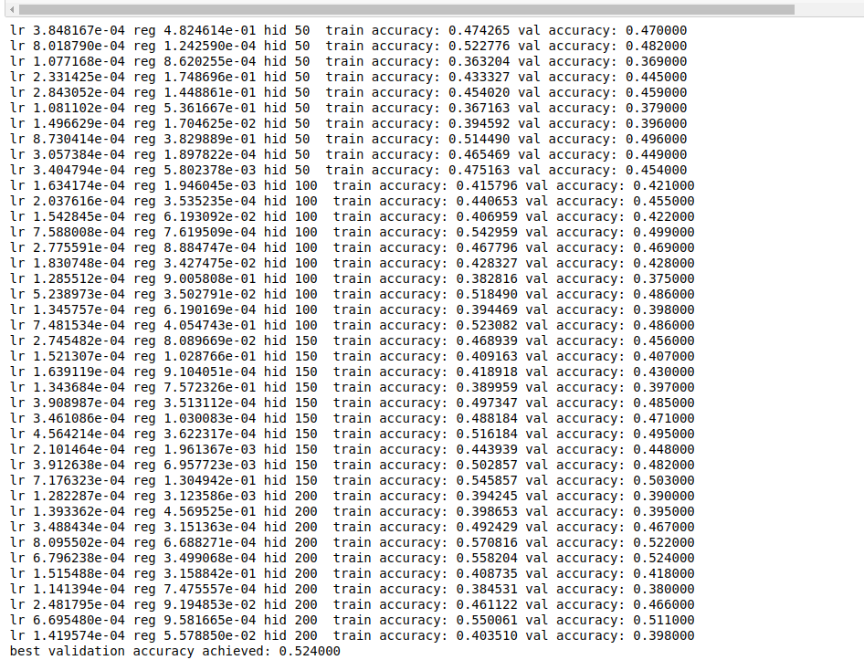
We found the en validation accuracy as 0.524000. This looks good for now. Then we visualize the weights of the best network.
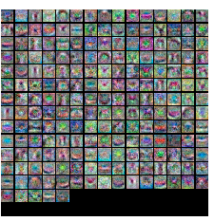

Finally, we evaluate our final trained network on the test set;

Inline Question
Now that you have trained a Neural Network classifier, you may find that your testing accuracy is much lower than the training accuracy. In what ways can we decrease this gap? Select all that apply.
- Train on a larger dataset.
- Add more hidden units.
- Increase the regularization strength.
- None of the above.

Answer:1 and 3

Explanation:
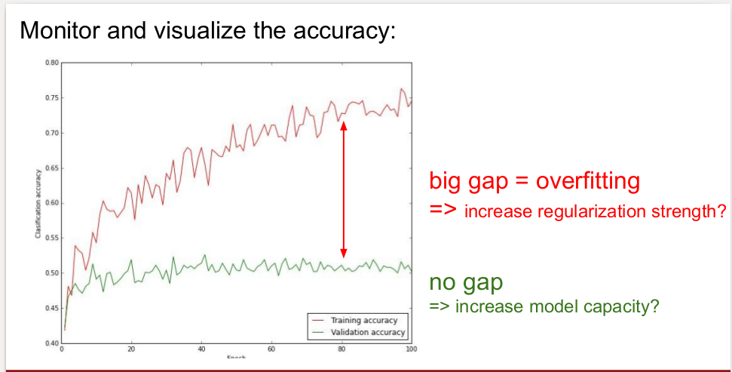

1. Train o a larger datasets:Big gap means overfitting. So training on a larger dataset prevents overfitting.[TRUE]

2. Add more hidden units:Increasing the number of hidden layers will cause accuracy in the test set to decrease. It will cause your network to overfit to the training set, that is, it will learn the training data, but it won't be able to generalize to new unseen data.[FALSE]

3: Increase the regularization strength: As we can see above, increasing the regularization strength prevents overfitting because it reduces the complexity of the model[TRUE]

